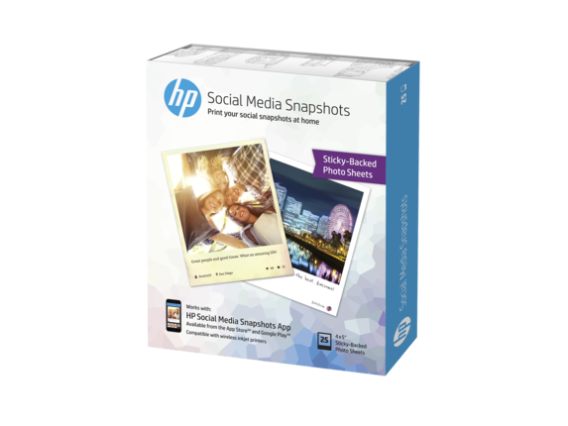
Printing Station
How to Print Directly from your phone:

- Download the HP Social Media Snapshots app
- From your mobile device, turn on WiFi and search for wireless networks. Select the printer, which will show up as ‘DIRECT-AD-HP ENVY 5660 series’ as shown on your printer's control panel.
- Enter the password: ___________
- In the HP Social Media Snapshots app choose from your photos on your cell phone, in Instagram, or on Facebook. Add a message and print!
- Make sure your paper size for the printer is set at 4”x6” (on Android) or 4”x5” (on Apple)
- Watch the printer as a prompt comes up to verify that you want to print. The print job will time out if you don’t select ‘ok’

